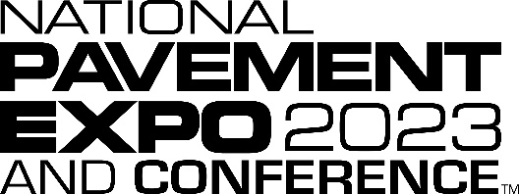

SPEAKER GUIDE TO EDUCATIONAL HANDOUTS
Educational Handouts
Conference attendees want to leave your session with actionable content to help them once they are back at their job site, in the office and with their team! To help attendees improve professionally as a result of the education sessions provided at National Pavement Expo and Conference, we ask each speaker to create an educational handout which will be shared electronically and via print at the Conference.
Your handout should:
- Be a cohesive resource to share along with your presentation, but not a print-out of the slides from within your PowerPoint Presentation.
- Expand on the learnings presented in your session/workshop, handouts help to guide attendees on how to apply the insight from the conference session.
- Your handout should standalone – providing a clear, valuable guide that someone could follow and benefit from even if they missed part or all of your session/workshop.
- Be strictly educational (company logos and information about a company’s services/products is not permitted).
- Be submitted as a PDF file.
Handout instructions:
- Please review Handout Template below (pages 2-4).
- Please submit your Handout by November 11, 2022. Link to submit will be provided in early November.

If you have questions or need assistance completing your Handout, please contact:
Madeline Kinney, Conference Content Manager, madeline.kinney@emeraldx.com
Kennedy Oglesby, Conference Manager, kennedy.oglesby@emeraldx.com
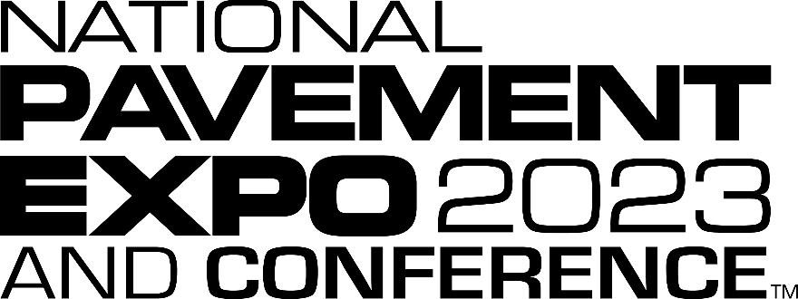

Session Title
Notes/Key Info:
Sidebars are great for calling out important points from your presentation, notes, and/or adding additional info for quick reference.
Feel free to add text or leave blank so that attendees can fill out on their own.

Speaker Name, Title, Company/Organization

OVERVIEW
Concisely explain the core mission/purpose of this session. Why is a new approach/action necessary (i.e., what’s the need, what improvements are needed to enhance existing processes/models?)

The objectives for this session are to:
Speaker’s response goes here

Methods/Strategies Covered in this session:
Speaker’s response goes here

Expected Outcomes for Attendees of this session:
Speaker’s response goes here

Optional – Insert Picture

SECTION #
Notes/Key Info:
Sidebars are great for calling out important points from your presentation, notes, and/or adding additional info for quick reference.
Feel free to add text or leave blank so that attendees can fill out on their own.

Title/Heading
Sections help to provide quick, concise and easy to read information related to your workshop or session. Sections can include any of the following:
- Discussion points
- Supporting Tips and Tricks
- Key information and takeaways from your presentation
- Scenarios/Examples
- Checklists
- Photos
- Diagrams
- Statistics – with proper citation to the source
- Q&A
- Concepts
- Best Practices
- References
- Guides
- Forms
- Charts and Graphs
- Additional Resources/Next Steps

Sections should include a title/header and follow in the same order to what is being displayed and discussed within the session/workshop. This helps to best amplify key topics within the presentation.
Speakers can determine how many sections needed for their handout.

SUMMARY AND CONTACT INFO
Notes/Key Info:
Sidebars are great for calling out important points from your presentation, notes, and/or adding additional info for quick reference.
Feel free to add text or leave blank so that attendees can fill out on their own.

Your summary can include 1-2 paragraphs giving a brief recap and/or “Lessons Learned” during the session/workshop. It can also include a checklist of action items for attendees to refer to and discuss with their team, on job sites, etc.

Insert a thank you and your contact info below:
Headshot (Optional)
Name
Email
Phone

